JECRC
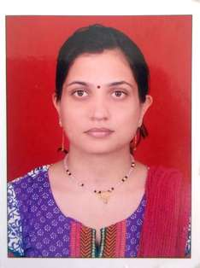
JAIPUR

INDIVIDUAL FACULTY DATA SHEET
Name of the faculty member | : | YAZUSHA SHARMA  **************
Present Designation | : | ASSISTANT PROFESSOR  ****************
Email Id:yazushasharma.ece@jecrc.ac.in
Contact Details:9982421234

I. Particulars of Educational Qualification: (only completed)

Category | Name of the Degree | Specialization | Year of Passing | Name of the College | Name of the University
UG | B.E. | E&C | 2007 | R.C.E.W.,JAIPUR | Raj. University
PG | M.Tech. | Digital Communication | 2015 | S.K.I.T.,Jaipur | Raj. Technical University
Ph.D.

II. Academic Experience : 04

III. Industrial Experience :

IV. Title of Ph.D. Thesis :

V. Awards/Achievements :

VI. Research/Specialization : optical communication

VII. Course Taught : EDC ,Control system, EMI, Microwave, DSP, Analog communication ,Digital communication

VIII. Refereed International Journal Publication : 01

IX. International Conference Proceeding :01

X. Books Written :

XI. M.Tech Thesis Guide :

XII. PHD Thesis Guide :

XIII. Professional Body Membership :

